HTNO:2403A51349
Batch:14
Assignment 9.1
Task 1: Task Description #1 (Documentation – Google-Style Docstrings for Python Functions)
- Task: Use AI to add Google-style docstrings to all functions in a given Python script.
- Instructions:
  - Prompt AI to generate docstrings without providing any input-output examples.
  - Ensure each docstring includes:
    - Function description
    - Parameters with type hints
    - Return values with type hints
    - Example usage
  - Review the generated docstrings for accuracy and formatting.
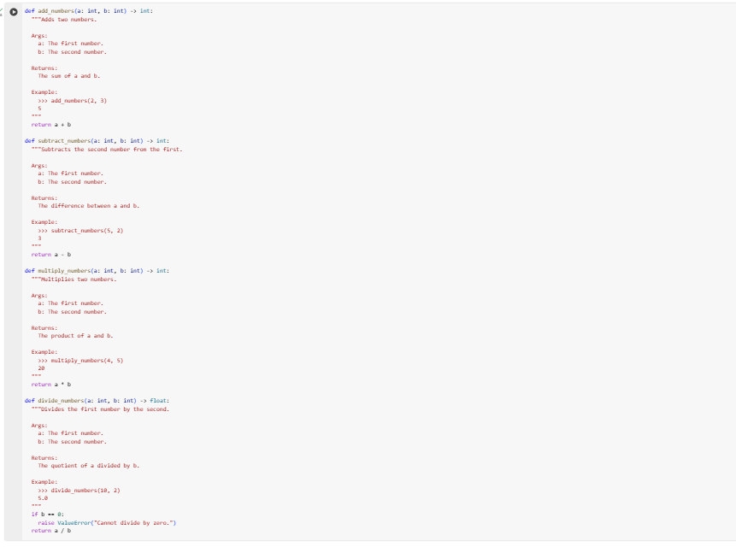

Task Description #2 (Documentation – Inline Comments for Complex Logic)
- Task: Use AI to add meaningful inline comments to a Python program explaining only complex logic parts.
- Instructions:
  - Provide a Python script without comments to the AI.
  - Instruct AI to skip obvious syntax explanations and focus only on tricky or non-intuitive code sections.
  - Verify that comments improve code readability and maintainability.

Before
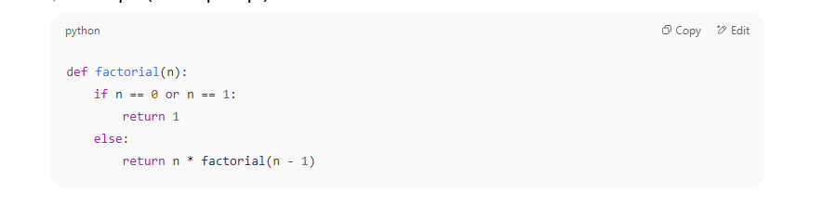
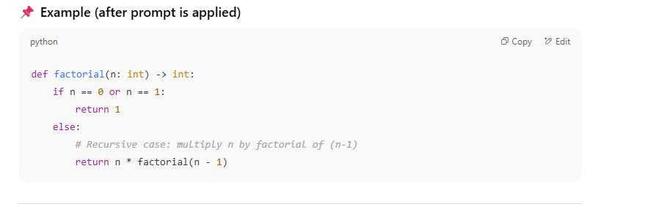
Task Description #3 (Documentation – Module-Level Documentation)
- Task: Use AI to create a module-level docstring summarizing the purpose, dependencies, and main functions/classes of a Python file.
- Instructions:
  - Supply the entire Python file to AI.
  - Instruct AI to write a single multi-line docstring at the top of the file.
  - Ensure the docstring clearly describes functionality and usage without rewriting the entire code.

Before: 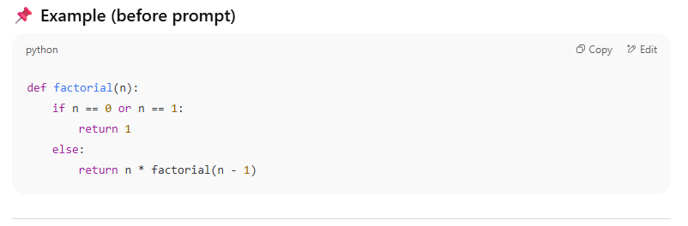
Output:

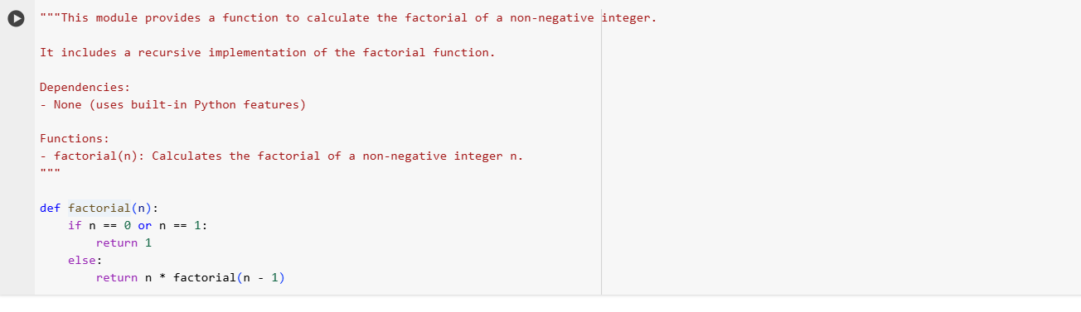
Task Description #4 (Documentation – Convert Comments to Structured Docstrings)
- Task: Use AI to transform existing inline comments into structured function docstrings following Google style.
- Instructions:
  - Provide AI with Python code containing inline comments.
  - Ask AI to move relevant details from comments into function docstrings.
  - Verify that the new docstrings keep the meaning intact while improving structure.

Before: 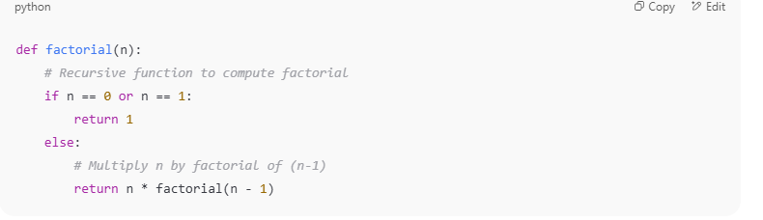
After:
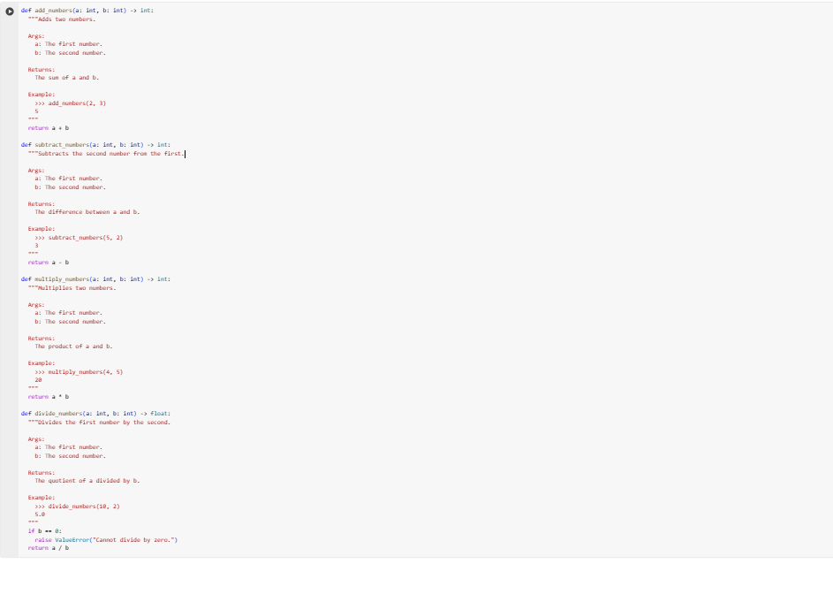
Task Description #5 (Documentation – Review and Correct Docstrings)
- Task: Use AI to identify and correct inaccuracies in existing docstrings.
- Instructions:
  - Provide Python code with outdated or incorrect docstrings.
  - Instruct AI to rewrite each docstring to match the current code behavior.

BEFORE:

BEFORE: 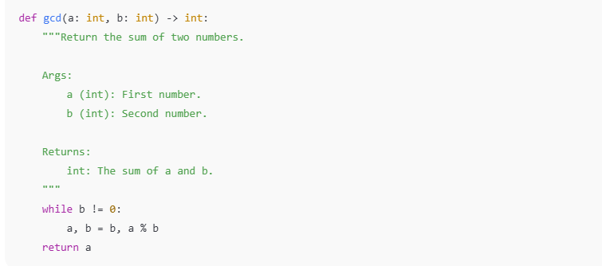
After:
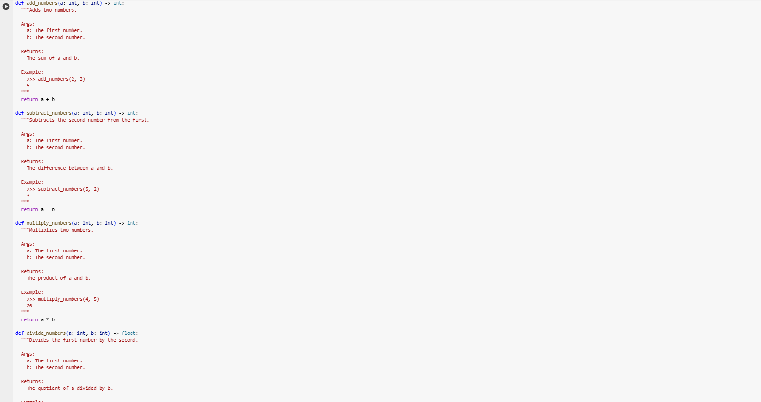
Task Description #6 (Documentation – Prompt Comparison Experiment)
- Task: Compare documentation output from a vague prompt and a detailed prompt for the same Python function.
- Instructions:
  - Create two prompts: one simple (“Add comments to this function”) and one detailed (“Add Google-style docstrings with parameters, return types, and examples”).
  - Use AI to process the same Python function with both prompts.
  - Analyze and record differences in quality, accuracy, and completeness.
- Expected Output #6:
  - A comparison table showing the results from both prompts with observations.